Fundamentals of programming (lab)

**Name:** Muhammad Ahmed Naseer

**Class:** ME-15,SEC-A

**Reg no.** 467276

**Assignment:** 1

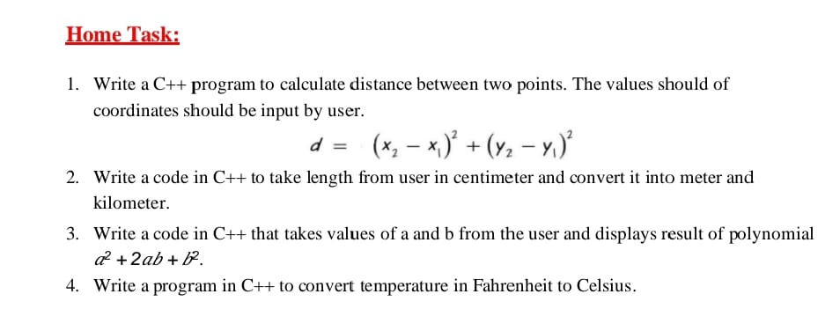

Question:1

#include <iostream>

using namespace std;

int main ()

{

int x1;

int x2;

int y1;

int y2;

cout<<"write x1 ";

cin>> x1;

cout<<"write x2 ";

cin>> x2;

cout<<"write y1 ";

cin>>y1;

cout<<"write y2 ";

cin>>y2;

int res;

cout<<"the distance between two points is ";

res=(x2-x1)*(x2-x1)+(y2-y1)*(y2-y1);

cout<<res<<endl;

return 0;

}

Question:2

#include<iostream>

using namespace std;

int main ()

{

float centimeters;

cout<<"enter values in centimeter " ;

cin>>centimeters;

float meters=centimeters/100;

float kilometers=centimeters/100000;

cout<<"the value in meters is ";

cout<<meters<<endl;

cout<<"the value in meters is ";

cout<<kilometers<<endl;

return 0;

}

Question:3

#include<iostream>

using namespace std;

int main()

{

cout<<"enter value of a ";

int a;

int b;

cin>>a;

cout<<"enter value of b ";

cin>>b;

int res;

cout<<"the answer is ";

res=a*a+2*a*b+b*b;

cout<<res<<endl;

return 0;

}

Question 4:

#include<iostream>

using namespace std;

int main()

{

float fahrenheit;

cout<<"enter value in fahrenheit ";

cin>>fahrenheit;

float celcius= (fahrenheit-32)*5/9;

cout<<"the value in celcius is ";

cout<<celcius;

return 0;

}